Framework

The framework supports the other components, which are the instruments that record data and the optional protection to prevent animal damage.

The design is essentially a weather station. The framework is the stand that holds the measuring components. Since the core measurements are near-surface reflected irradiance, different frame variants are used over vegetation of various heights.

Frame variants for various heights of vegetation



The framework section covers the mantis steel support frame. This section provides the information you need to hand-build a frame, or have the parts machined.

The components *mounted on* the frame will be covered in separate sections. The major parts of this mounted hardware are shown here, to illustrate the function of frame pieces, but the mounted parts are only blocked in as to general shape and position.

We first cover the hand-built frame and then alternatives. The hand-built frame is the design you would most likely use if you were constructing a frame using hand tools. It uses relatively small off-the-shelf stock. It might serve as a useful mock-up before general production of frames, especially if you are going to vary the designs we present.

The first alternative we offer is a slightly different design, streamlined in some ways for general production. This is a variant you might use if you are going to have the pieces bent and drilled by a machine shop, typically a number of sets. Some of the metal stock is a bit awkward to work with by hand due to large size.

The next alternative is an extension for placing the irradiance sensors over taller vegetation. Finally, we give an off-the-shelf alternative, a frame you can buy ready-made, though at higher cost.

The basic mantis frame, example of a manually built prototype:

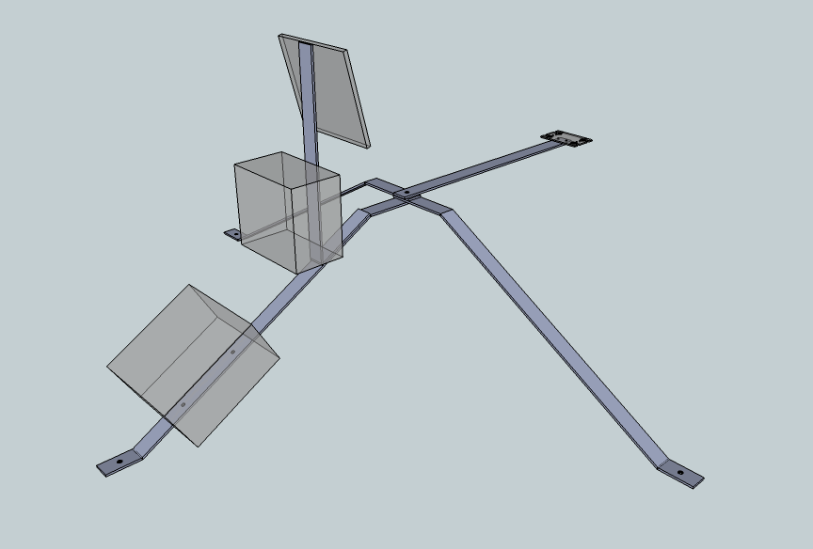

This is the basic mantis frame, complete with the major mounted parts shown as if semi-transparent. These parts are named below, in discussion of the frame pieces they mount to.

The overall configuration is like an asymmetrical tripod. The "head" is the end towards the right background. It holds the irradiance sensors. When deployed, the head would be towards the equator (south in the northern hemisphere, north in the southern hemisphere) to minimize its view area being shaded by the other components.

This frame would be suitable for use over short vegetation such as prairie, alpine meadow, or tundra. The head would be on the order of half a meter above ground, and the irradiance sensors on the head would then "see" a roughly circular area of the ground about a meter in diameter. So this would work for vegetation up to a few tens of cm tall. As discussed in the "Instrumentation" section, there is no precise meaning to "vegetation canopy height", so it is more salient to think in terms of "what the sensors see" rather than "height above the vegetation".

Terrain is always uneven, so the mantis frame is meant to be bent and flexed to get the irradiance sensors leveled and in the desired position. It is understood that angles and bends in the plans that follow can only be approximate.

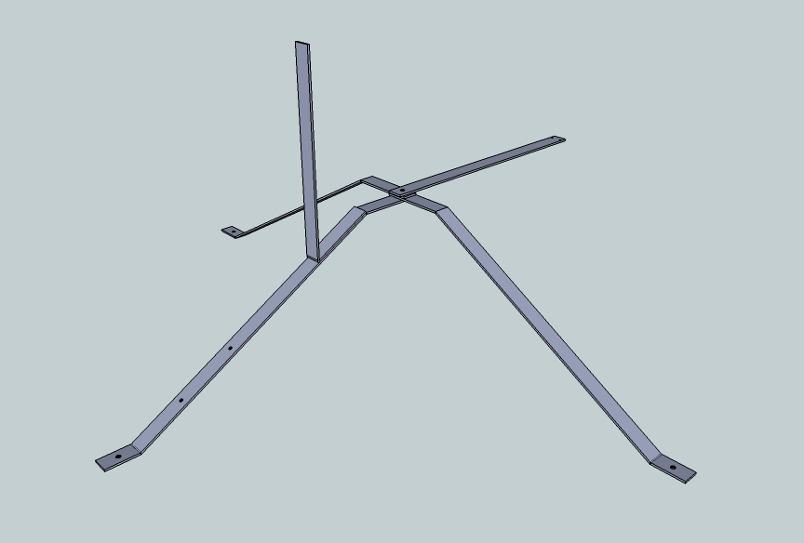

Neck

Side leg

Side leg

Back leg

Upright

This is the mantis frame showing only the steel pieces.

All pieces are made from steel stock 1.5" wide and 3/16" thick. This stock is readily available from hardware stores as pre-cut lengths for prototyping, as well as in bulk from commercial fabricators when you are ready to have the parts for multiple frames bent and drilled.

This size stock is sturdy enough to hold its shape in the rough handling of field deployment, and not easily damaged by livestock or wildlife. It is light enough to be flexed and bent for field adjustments without too much trouble.

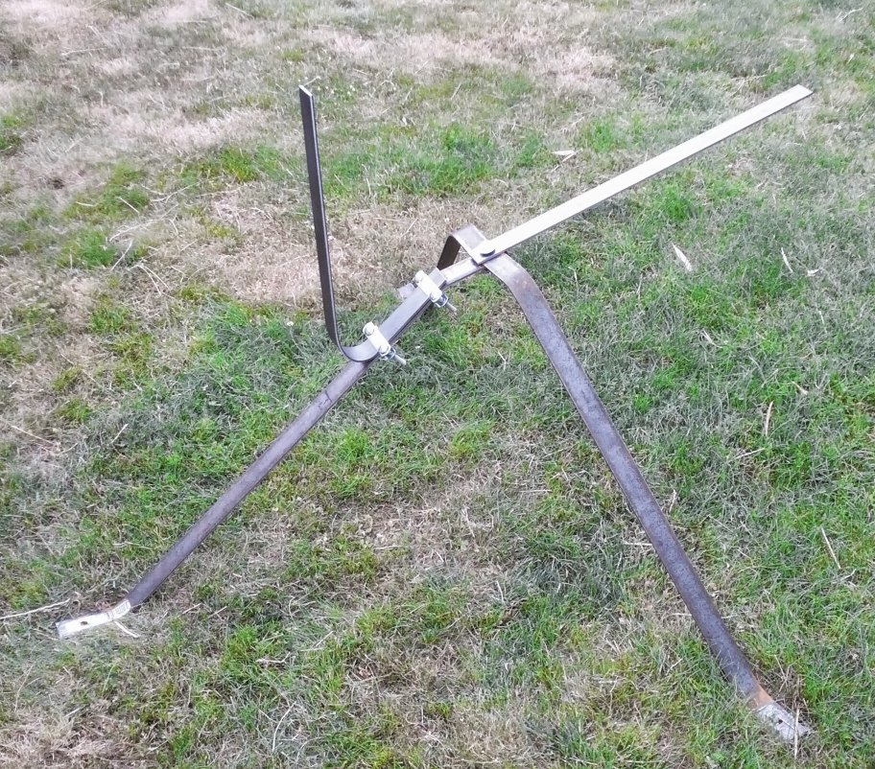

When building a frame using hand tools, you may not be able to bend the steel pieces as sharply as shown in the graphics, but the overall idea is the same. Construction details are covered in the "assembly" section below.

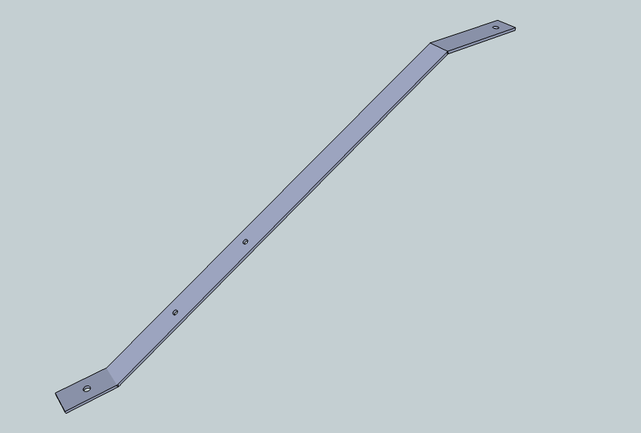

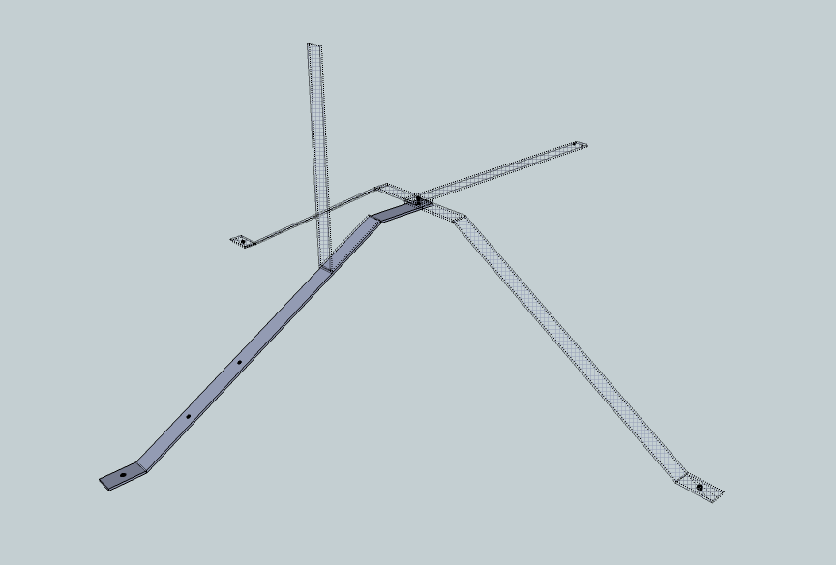

Context

The back leg piece joins to the side legs and the neck at the main cross mounting hole at the top.

The hole in the foot is for a lag bolt to anchor into the ground, detailed later in the "assembly" section.

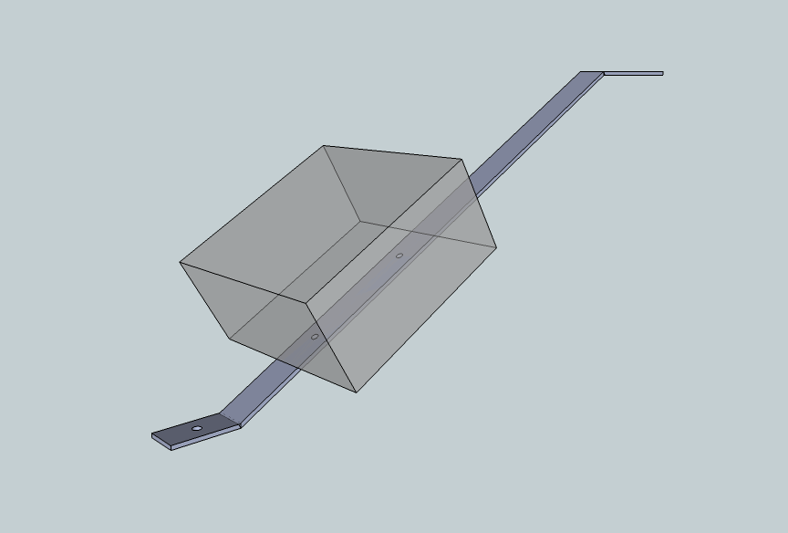

The two smaller holes along the middle of this leg are for mounting the junction box (if used, covered in the "protection" section). The general shape and position of the junction box is shown in the inset to the right.

The back leg piece can be made from a 3-foot piece of steel bar, of the steel stock 1.5" wide and 3/16" thick described above. This is a standard length available in hardware stores.

Measurements on the back leg piece are below (diagram not to scale):

L7

L6

L5

L4

L3

L2

L1

L0

L0 Begin point

L1 Foot anchor hole, 25/64" diameter, centered between sides of bar, centered between L0 and L2, 1.5" from each.

L2 Foot bend, approx. [60˚], 3" from L0 to L2.

L3 First junction box mounting hole, 5/16" diameter, centered between sides of bar, approx. [5"] from L2. Placement is not critical, but distance between L3 and L4 must be exactly [7 and 5/8"] ([7.625"]) on center (hole center to hole center).

L4 Second junction box mounting hole, [5/16"] diameter, centered between sides of bar. Placement is not critical, but distance between L3 and L4 must be exactly [7-5/8"] on center.

L5 Spine bend, approx. [60˚], [29"] from L2. Total length of steel bar from L0 is [32"].

L6 Frame cross mounting hole, 25/64" diameter, centered between sides of bar, [3"] from L5, [1"] from L7.

L7 End point of piece. Total length of steel bar from L0 is [36"].

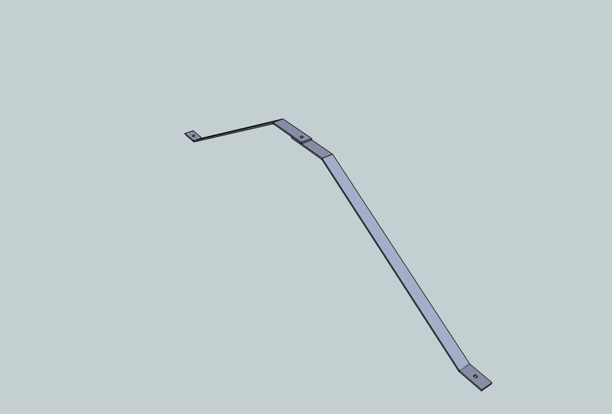

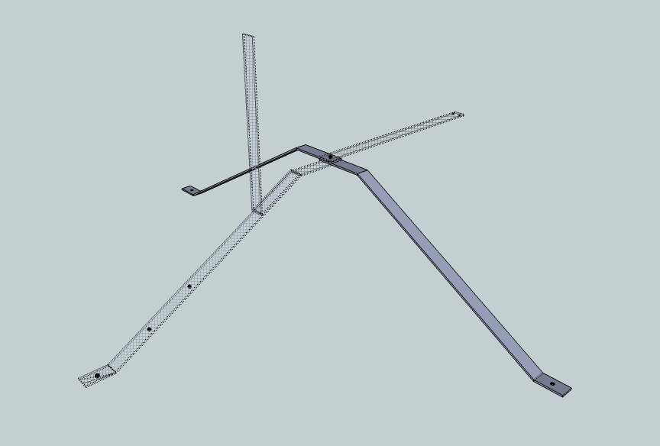

Context

The two side legs are the same as the back leg except you do not need to drill mounting holes for the junction box. You might have these holes drilled if you are getting these pieces mass produced and you wish to make the side and back legs interchangeable.

In the machined variation covered later, these two separate legs are replaced by a single continuous crosspiece. This is easy for a machine shop to do, but can be awkward when building a prototype using only hand tools.

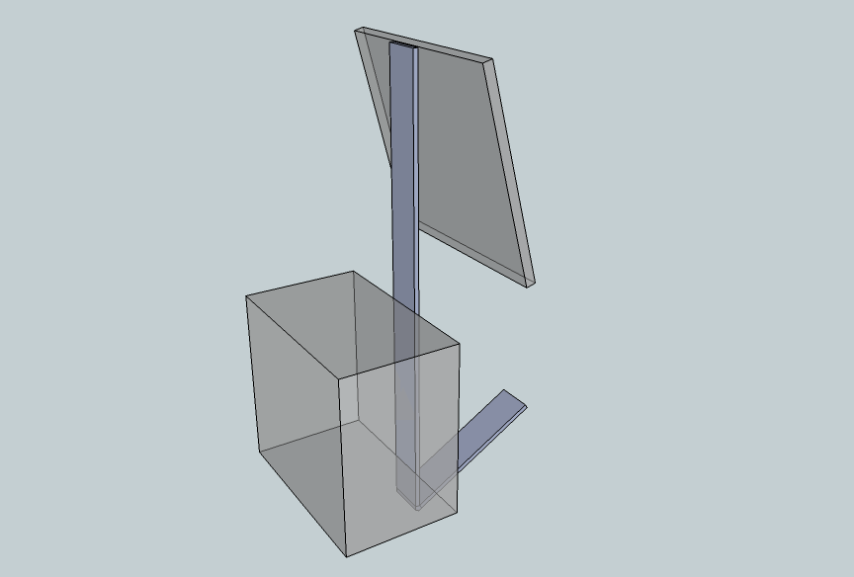The upright piece is strapped on to the back leg (assembly details later).

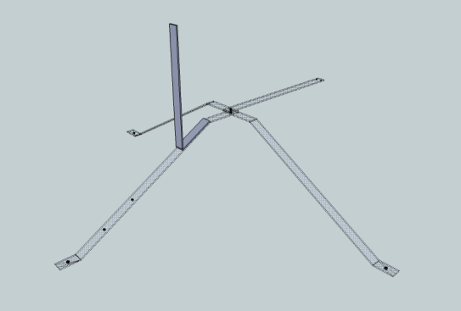

Context

The upright piece does not have any holes. It holds the solar panel and the data logger (attachment details are in the "instrumentation" section).

Both of these components are illustrated here as if semi-transparent and details of their mounting hardware are left out.

The solar panel position is the flat plate higher up the vertical section. Here, it is angled as if to track a low sun at very high latitude, but the slope is adjustable.

The data logger position is the block further down the vertical member.

Measurements on the upright piece are as shown (diagram not to scale):

U2

U0

U1

U0 Begin point

U1 Upward bend, approx. [60˚], [6"] from U0'

U2 End point of piece, [18"] from U1. Total length of steel bar from U0 is [24"].

You can make the upright piece from a 2' long section of the steel stock, if you can find that length pre-cut. Otherwise, get a 4' section and cut it in half. You can use the other half for the neck (described next).

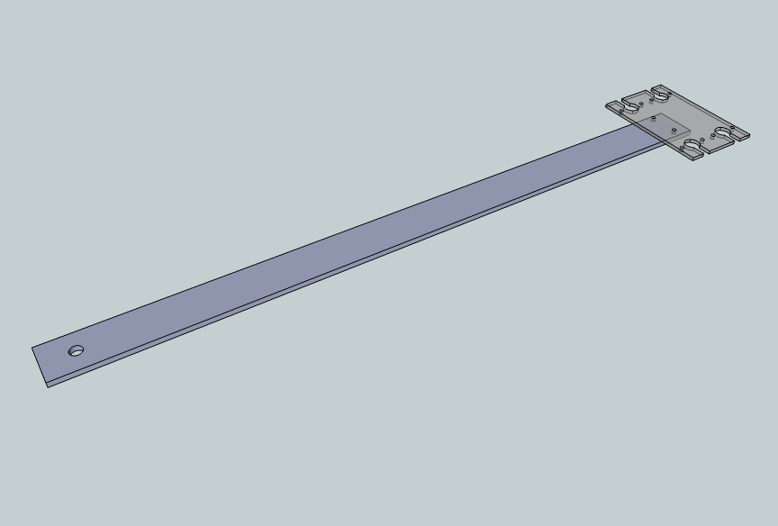

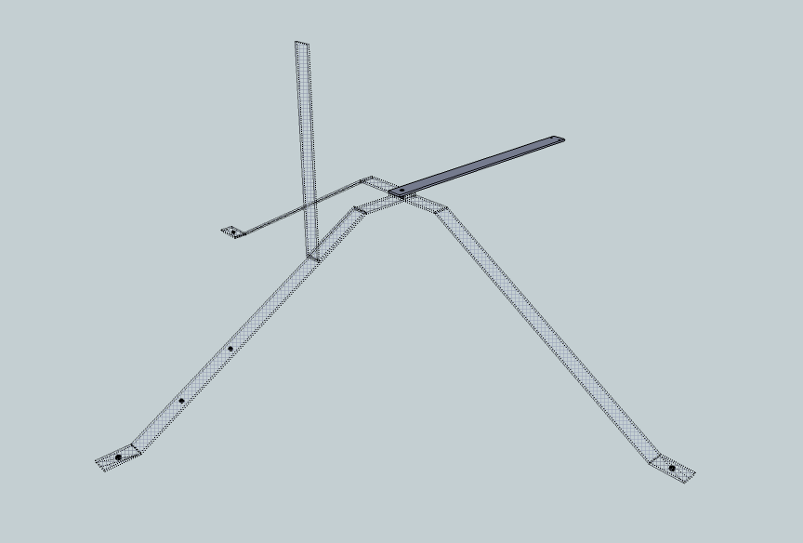

Context

You can make the neck piece from a 2' section of steel stock, if you can find that length pre-cut, or the other half of a 4' piece used for the upright.

Measurements on the neck piece are as indicated (diagram not to scale):

N4

N1

N0

N2 and N3

N0 Begin point

N1 Frame cross mounting hole, 25/64" diameter, centered between sides of bar, [1"] from N0.

N2 and N3: NDVI bracket mounting holes, details below.

N6 End point of piece, [24"] total length of steel bar from N0.

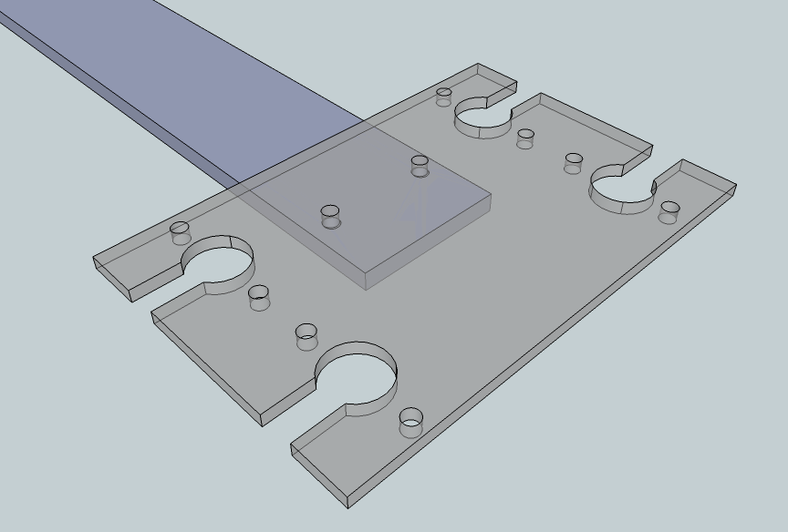

The head end of the neck piece holds the aluminum "NDVI plate", detailed in the "instrumentation" section. The holes in the frame piece are one of the few critical dimensions.

Measurements in the head area are as shown (diagram not to scale):

N4

N2 and N3

N2 and N3: NDVI plate mounting holes, [5/32"] diameter, [0.66"] from the bar end at N4. Holes are spaced equally away from the center line; each is 0.53" out from the center line and therefore 1.06" on center apart from each other.

The hole positions along the neck bar are not critical but the hole diameter and spacing apart from each other are, to mate with the NDVI plate. (The given hole distance from the bar end ([0.66"]) brings the bar halfway under the NDVI plate.)

Frame assembly

Wherever available, we used all stainless steel fasteners (nuts, bolts, etc.). We deployed instruments in harsh environments such as acidic-soil tundra. Stainless steel meant we did not have to worry about corrosion of the fasteners.

You can use non-stainless fasteners, such as galvanized, if you will use instruments in less harsh environments or are willing to replace fasteners in a few years if they rust.

The frames are made of regular steel, and so are susceptible to rust. We painted the frame pieces with rust-resisting spray paint after bending and drilling.

You will find it easiest to bend the steel bars by clamping them in a bench vise. A vise is also helpful for holding the steel while drilling holes. In a pinch, you can use "pipe clamps", as shown below, to bend the steel.

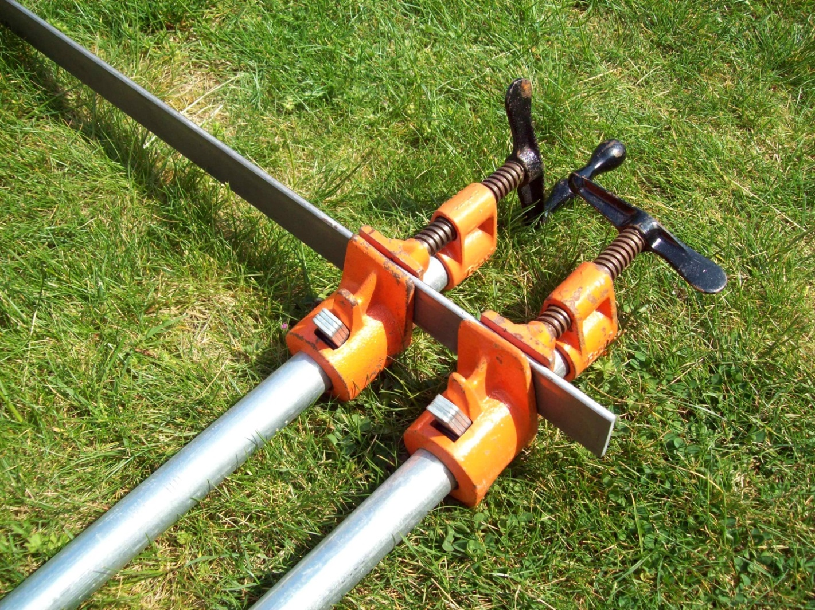

The orange parts are what's sold as the clamps, and then each one screws on to a length of threaded iron pipe as long as you want (we used 5' lengths). The pipes are the silver rods extending out of the picture at the bottom. You can put two clamps on to a steel bar close together, as shown here. Then, you can see, if you were to move the far ends of the pipes, you would get a great deal of concentrated leverage to bend or twist the steel.

Clamps like this are more useful for the final adjustments when deploying a mantis. You can use them to twist and flex the bars, to compensate for uneven ground. If you use clamps like this for the major bends, you will get more control by putting the two clamps on from opposite edges of the bar, rather than the same edge as shown here.

Pipe clamps cost about $14 each ($28 for the pair) at Home Depot (SKU 361933). They go onto 3/4" (nominal size) pipe, which you can get cut and threaded at most hardware stores. Home Depot sells a 5' length pre-threaded for about $15 (SKU 312268).

Assembly details:



Context

The legs, neck, and crossbar are held together by a 3/8" cap screw (bolt), two flat washers, a lock washer, and a 3/8" nut.

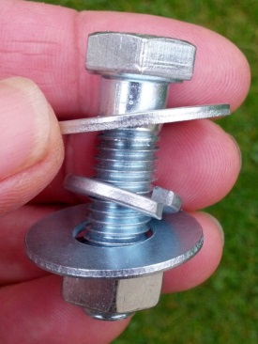

Main cross hardware

The length of bolt you need will depend on how many thicknesses of steel it goes through.

For example, in this design, there are four thicknesses: The bolt has to go through holes in the back leg, the neck, and each of the two side legs.

In the "machine shop" variant we give next, the two side legs are replaced by a continuous cross piece, so the bolt only goes through three thicknesses of steel.

|  |  |
| --- | --- |
| Thicknesses of steel | Cap screw length, inches |
| 2 | 1 |
| 3 | 1.25 |
| 4 | 1.5 |

In another variant we mention (that we no longer use), where the back leg and neck were continuous, the bolt only had to go through two thicknesses of steel.

A 1.5" bolt will work for all cases, though it may be longer than needed.

We used all stainless steel to avoid corrosion concerns. Galvanized steel would be serviceable in most situations. We give Fastenal part numbers in the table below, though these components are generally available at hardware stores.

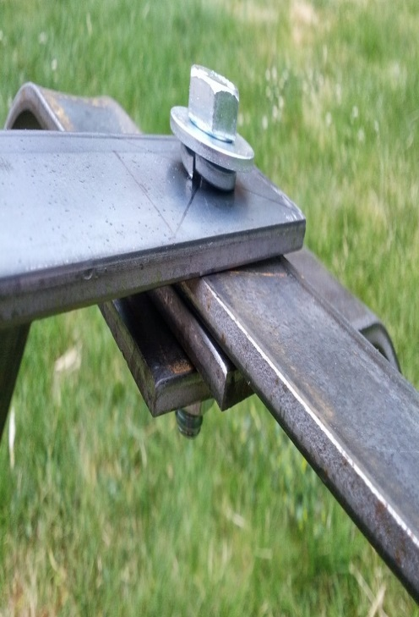

Assembly through 4 layers of steel (not completely tightened yet).

Part numbers are for individual pieces. Price each will be less in bulk, e.g. packages of 50.

|  |  |  |
| --- | --- | --- |
| Fastenal part number | Detail | Number needed per frame (* indicates variant choices) |
| 70105 | 3/8"-16 x 1" 18-8 Stainless Steel Hex Cap Screw | 1* |
| 70107 | 3/8"-16 x 1-1/4" 18-8 Stainless Steel Hex Cap Screw | 1* |
| 70109 | 3/8"-16 x 1-1/2" 18-8 Stainless Steel Hex Cap Screw | 1* |
| 70712 | 3/8"-16 18-8 Stainless Steel Finished Hex Nut | 1 |
| 71018 | 3/8" x 1" 18-8 Stainless Steel Flat Washer | 2 |
| 71067 | 3/8" 18-8 Stainless Steel Medium Split Lock Washer | 1 |

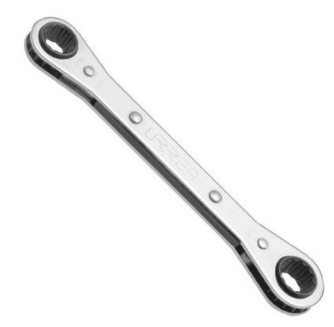

Ratchet wrench

A convenient tool for assembly is a ratchet wrench. The size we found most useful has a 1/2" box on one end and a 9/16" box on the other. The 9/16" box fits the main junction nut and bolt here, and the lag bolt foot anchors, described later. The 1/2" box fits the flange nuts, covered in the next section.

This type of wrench is readily available from hardware stores such as Home Depot, or ordered online from McMaster-Carr



Context

We wanted to attach the upright section of the frame to the back leg in a way that was field adjustable.

The picture below illustrates the best way we found.

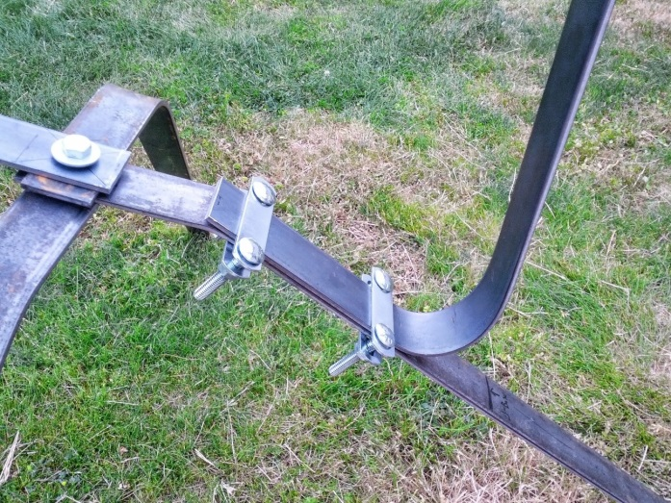

The key piece is a metal part called a "U-bolt plate". This is Fastenal part number 42082 (#3 U-Bolt Plate 3/4" Wide x 3 1/8" OAL 1 3/8" between slots). It is a roughly rectangular strap of metal with two holes. The holes are intended to line up with the legs of a U-bolt, but we repurposed it.

  
U-bolt plate

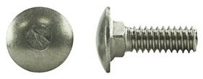  
carriage bolt,  
 top and side views

The other main parts are "carriage bolts". We used bolts of length 1" (5/16-18 x 1), which is Fastenal part number 1174430 (package of 50) or 74430 (single) in stainless steel, or part number 1128318 (package of 100) or 28318 (single) in galvanized. (The U-bolt plates themselves are only available in galvanized.)

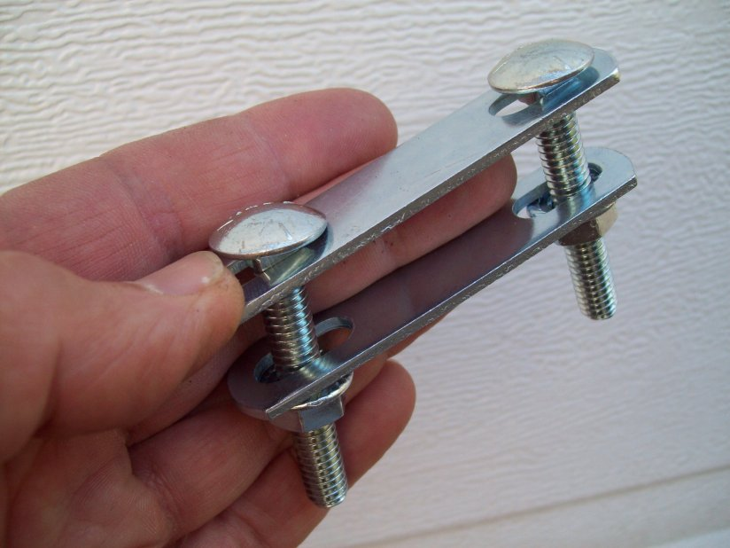  
bolt plate "sandwich"

The square shoulders of carriage bolts drop into the oval slots of the U-bolt plate and eliminate the need for any lock washers on the head end. We used two "sandwiches" like this for holding the upright piece onto the back leg. The picture shows somewhat longer carriage bolts than needed, but the idea is the same. The "sandwiches" clamp the two steel straps together.

We also used this U-bolt plate technique for mounting some of the instruments to the frame (see the Instrumentation section), and in the taller frame variants.

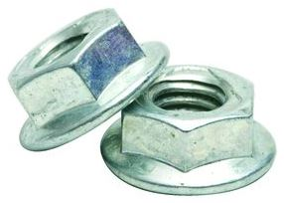  
flange nuts

The final parts that complete each "sandwich" are flange locknuts (5/16-18). These have serrations on the bottom, which eliminate the need for separate lock washers. These are Fastenal part number 0129151.

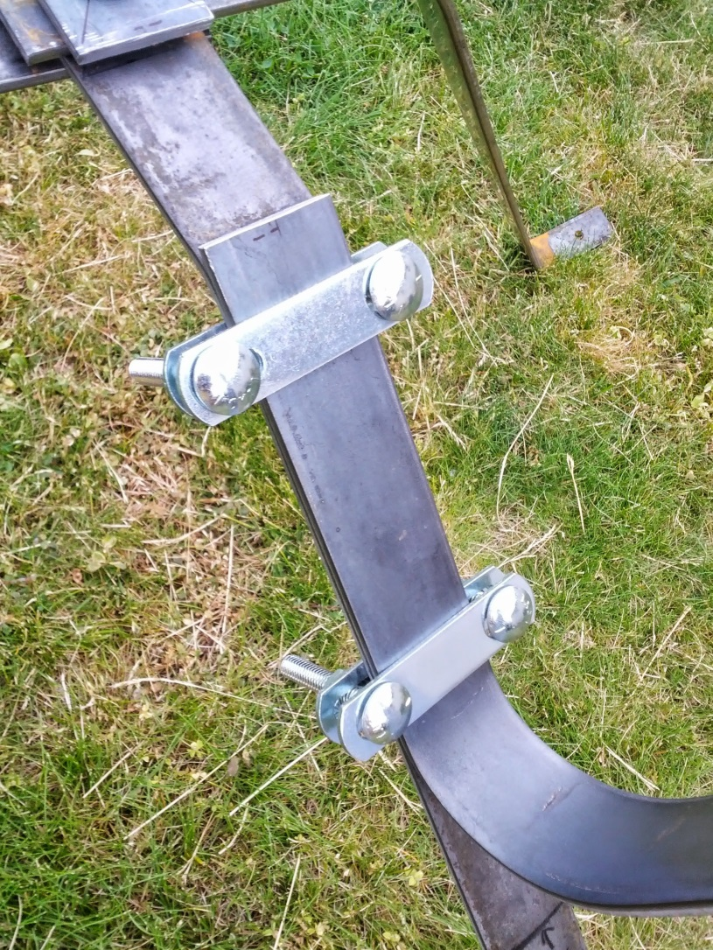

The connection between the upright piece and the rest of the frame is field-adjustable using only a wrench.

When you loosen the flange nuts, you can slide the upright piece up or down along the back leg, to conveniently position the instrumentation. Then, tightening the nuts holds the steel bars firmly together.

We anchored the mantis feet into the ground with 6-inch stainless steel lag screws (5/16 x 6" 18-8 Stainless Steel Hex Lag Screw, Fastenal SKU: 74518). We used stainless steel to avoid any corrosion concerns, but galvanized steel would be serviceable in most conditions. A six-inch length was more than sufficient to grip into turf-like substrates such as meadow. In sandy substrates, they mainly provided sliding friction to keep the feet from randomly splaying.



Context

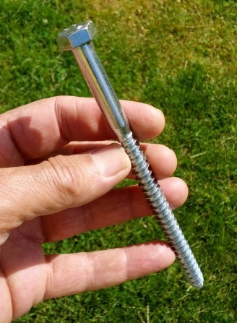 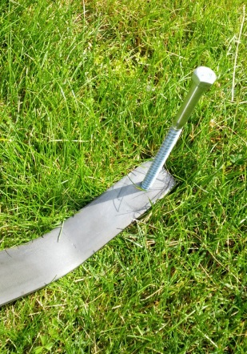 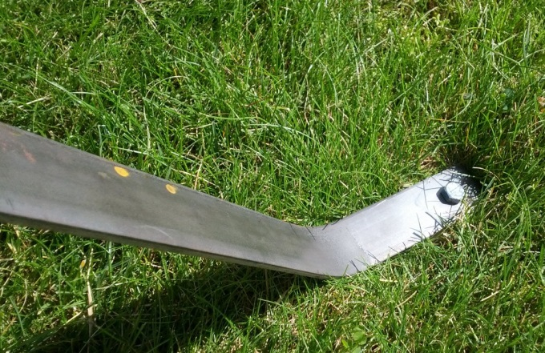

We were able to drive the lag screws into arctic tundra with a large drill, when the ground was still too solidly frozen to pound in other supports like re-bar. After ending a deployment in the fall and bringing in the frames, we could leave the screws frozen in the tundra all winter, for exact re-emplacement of the frames next season. In the spring, we unscrewed the fasteners from the icy ground, placed the frame feet, and screwed the fasteners back in.

We tried longer lag screws, up to 18". However, we found screws this long did not provide significant additional anchoring, and typically ran into rocks and could not be driven in full length anyway. The price each goes up steeply with length, especially for stainless steel.

Variant, the production frame:

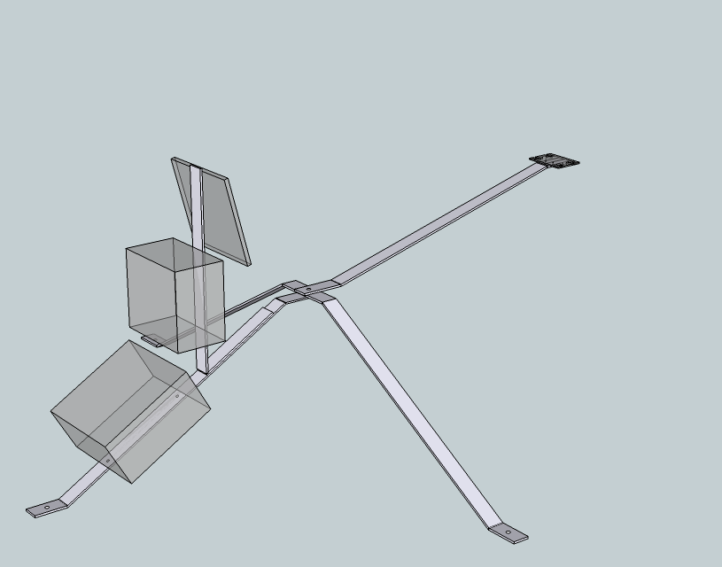

If you are having frame pieces cut, bent, and drilled by a machine shop, you are not limited by off-the shelf lengths of steel. The following variant is slightly optimized for dimensions.

The main difference in construction is that the two side legs are combined into a single crosspiece.

We originally designed the frame to have a continuous piece consisting of the back leg and the neck. However, in some experiments we needed to measure gas exchange and do other procedures on the ground area the irradiance sensors monitor. It was useful to be able to swing the neck aside temporarily. This was far easier than removing and replacing the entire frame and all its instrumentation.

Having the back leg and neck as separate pieces also facilitates extensions for taller vegetation, described in the next variant.

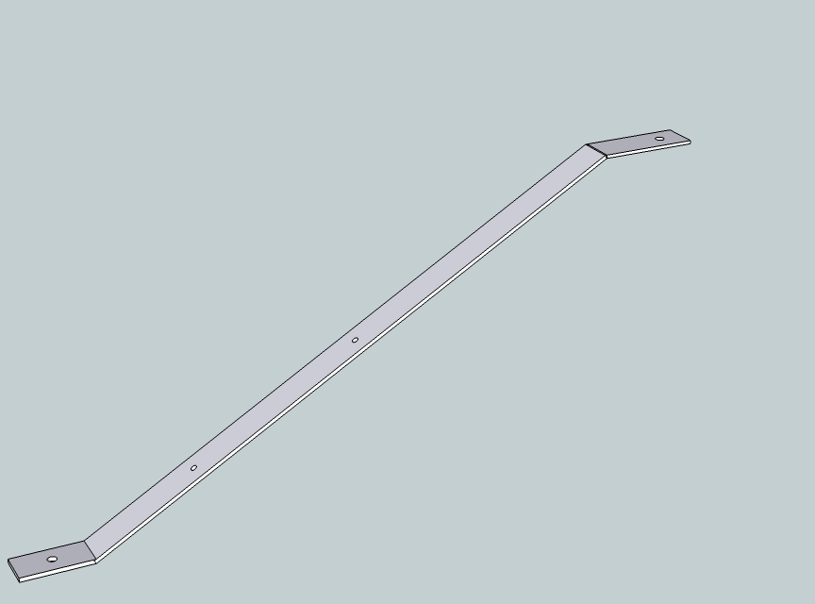

The back leg piece is similar to the previous design.

Measurements on the back leg piece are below (diagram not to scale):

L7

L6

L5

L4

L3

L2

L1

L0

L0 Begin point

L1 Foot anchor hole, 25/64" diameter, centered between sides of bar, centered between L0 and L2, 1.5" from each.

L2 Foot bend, approx. [60˚], 3" from L0 to L2.

L3 First junction box mounting hole, 5/16"diameter, centered between sides of bar, approx. [5"] from L2. Placement is not critical, but distance between L3 and L4 must be exactly 7 and 5/8" on center (hole center to hole center).

L4 Second junction box mounting hole, 5/16"diameter, centered between sides of bar. Placement is not critical, but distance between L3 and L4 must be exactly 7-5/8" on center.

L5 Spine bend, approx. [60˚], [25.5"] from L2. Total length of steel bar from L0 is [28.5"].

L6 Frame cross mounting hole, 25/64" diameter, centered between sides of bar, [3"] from L5, [1"] from L7.

L7 End point of piece. Total length of steel bar from L0 is [32.5"].

The neck piece.

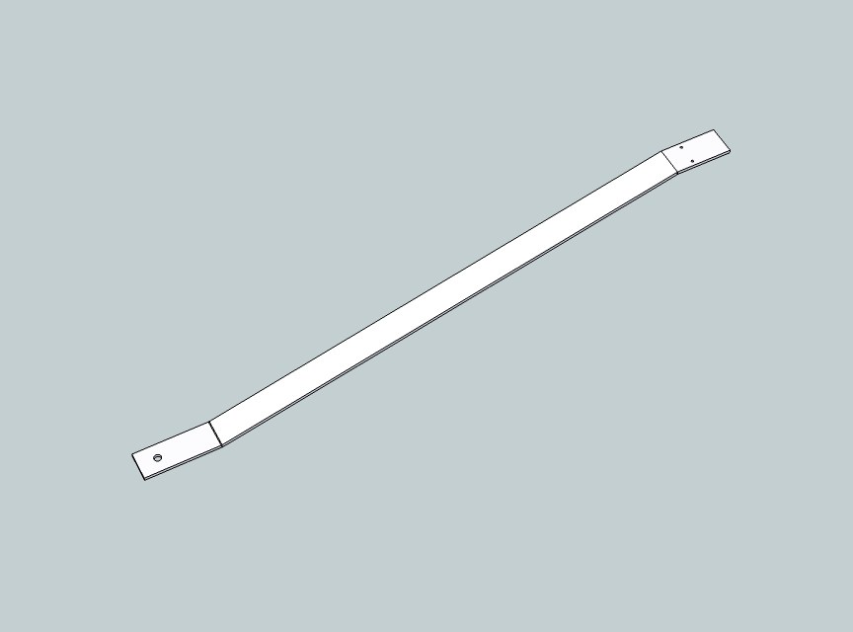

As in the previous design, the neck piece joins the leg and crossbar at the main cross mounting hole at the bottom. The two small holes near the top are for mounting the NDVI plate.

Measurements on the neck piece are as indicated (diagram not to scale):

N6

N3

N2

N1

N0

N4 and N5

N0 Begin point

N1 Frame cross mounting hole, 25/64" diameter, centered between sides of bar, [1"] from N0, [3"] from N2.

N2 Neck bend, approx. [30˚], [3"] from N1. [is there a neck bend here?]

N3 Head bend, approx. [30˚]. Total length of steel bar from N0 is [22"].

N4 and N5: NDVI bracket mounting holes, details below.

N6 End point of piece, [25"] total length of steel bar from N0.

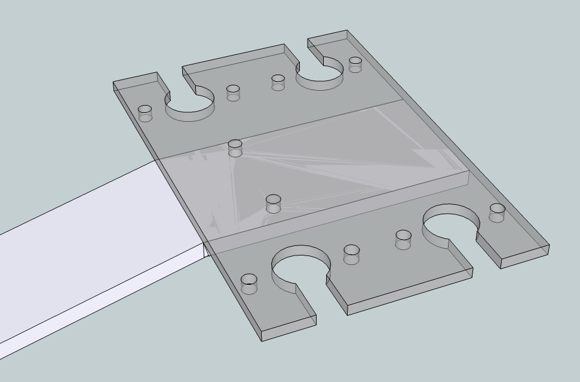

The head of the neck piece, illustrating the NDVI plate as if semi-transparent to show its placement on the frame [is this correct?].

Measurements in the head area are as shown (diagram not to scale):

N6

N3

N4 and N5

N4 and N5: NDVI bracket mounting holes, 5/32" diameter, [2"] from the bar end at N6 and [1"] from N3. Holes are spaced equally away from the center line; each is 0.53" out from the center line and therefore 1.06" on center apart from each other. The hole positions along the bar are not critical but their diameter and spacing apart are, to mate with the NDVI plate.

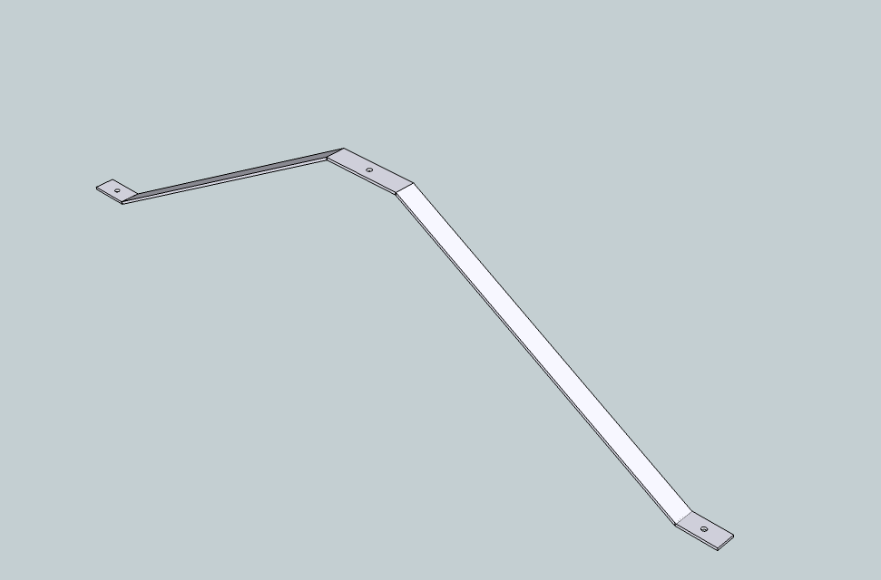The crossbar

The crossbar replaces the two discreet side legs of the previous design. It joins to the leg and the neck pieces at the hole in the middle.

As in the previous design, the two holes in the feet are for lag screws to anchor the mantis to the ground.

Measurements on the crossbar are as indicated (diagram not to scale):

C5

C3

C8

C7

C6

C1

C2

C0

C4

C0 Begin point

C1 Foot anchor hole, 25/64" diameter, centered between sides of bar, [1.5"] from C0, [1.5"] from C2.

C2 Foot bend, approx. [60˚], [3"] from C0.

C3 Upper bend, approx. [60˚], [25.5"] from C2. Total length of steel bar from C0 is [28.5"].

C4 Main cross mounting hole, 25/64" diameter, centered between sides of bar, [3"] from C3 and [3"] from C5. Total length of steel bar from C0 is [31.5"].

C5 Symmetrical with C3.

C6 Symmetrical with C2.

C7 Symmetrical with C1.

C8 Symmetrical with C0. Total length of steel bar from C0 is [63"].

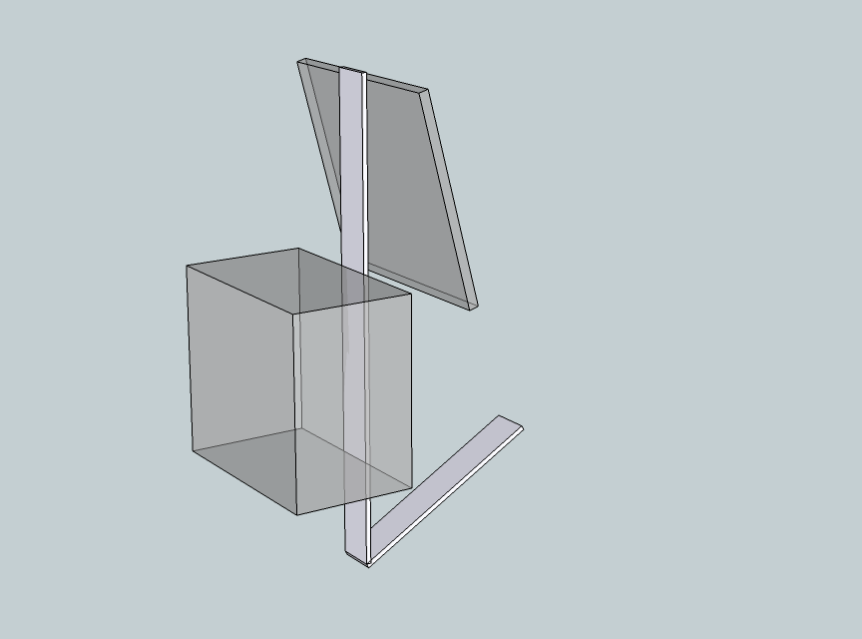

The upright piece is similar to that in the previous design.

Measurements on the upright piece are as shown below (diagram not to scale):

U2

U0

U1

U0 Begin point

U1 Upward bend, approx. [60˚], [8"] from U0'

U2 End point of piece, [18"] from U1. Total length of steel bar from U0 is [26"].

Variant: "Giraffe" frame for taller vegetation.

You can adapt the frames for taller vegetation by simply using a longer neck. However, here is an idea for a general purpose neck extension that is adjustable up to nearly 2m height.

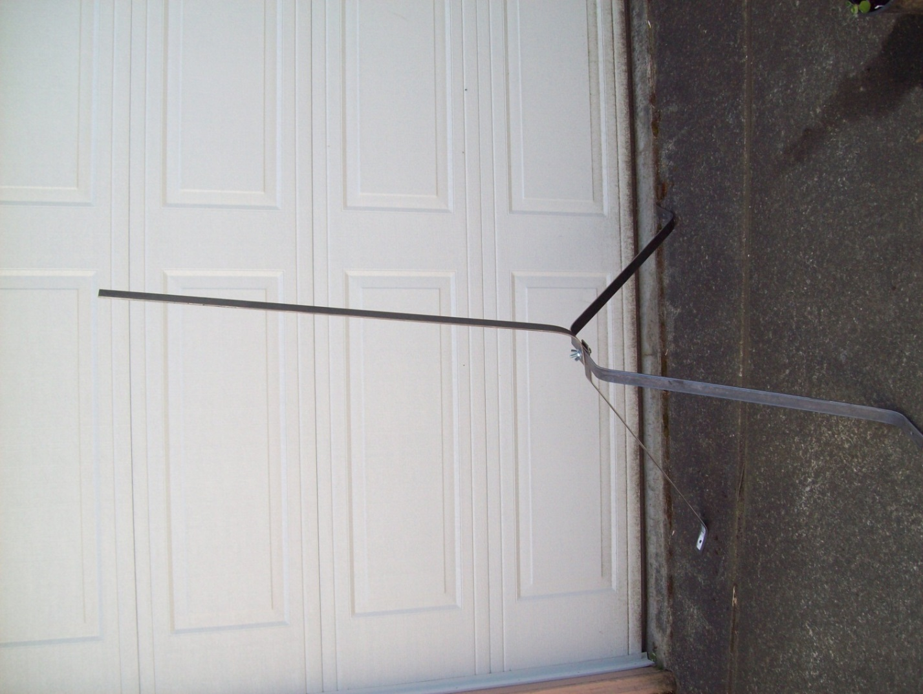

Replace the frame neck with a bar of steel stock. A 48" bar is shown here. You only need to drill one new hole in this bar, for mounting at the main cross junction.

Attach the neck piece you took off the frame onto this long bar using the same "U-bolt plate sandwich" method as for the upright piece.

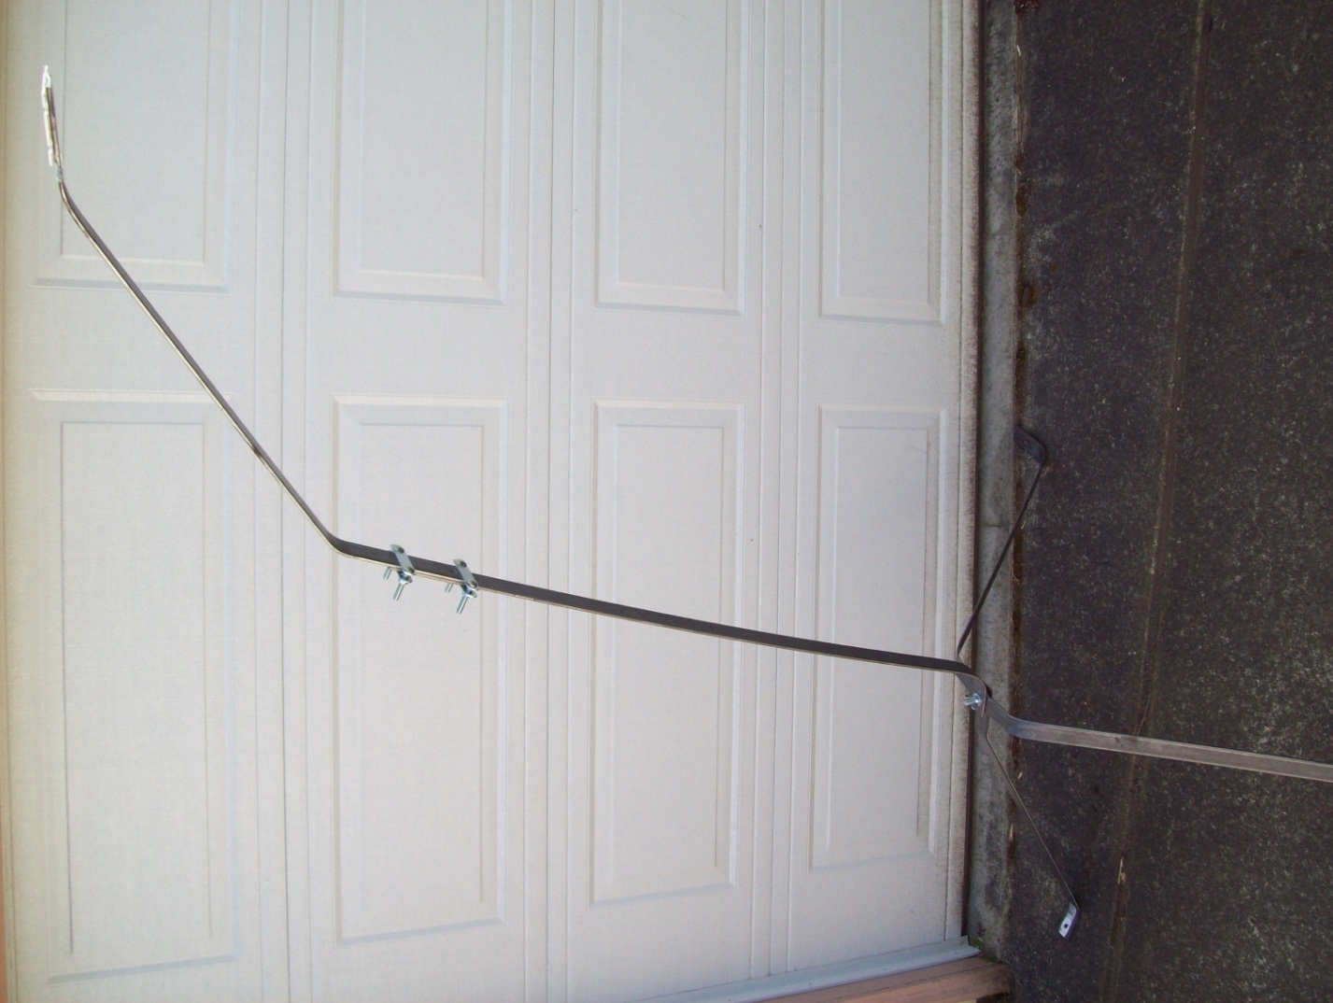

You will have to re-bend the existing neck. You may have less adjustment to do if you take the NDVI plate off and flip it to the other side of the neck piece. In any case, you can use the existing mounting holes in the neck bar to fit the NDVI plate.

Using the 48" extension bar, you can get the irradiance sensors up to about 185 cm maximum height above the ground, and this range is continuously adjustable.

Raising the sensor heads up will tend to bring parts of the mantis frame, such as the legs and feet, into the sensors' downward field of view. You will need to make trade-offs between bending the neck extension out vs. up. Too far out will counterbalance the weight of the instrument boxes and the mantis will tend to topple forward. If the mantis legs will be obscured from the sensors' view by lower vegetation, then there's no reason to go out so far.

Variant: Off-the-shelf frame. Convenient but more expensive.

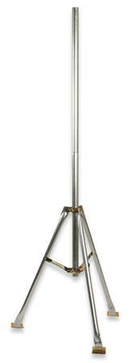

Onset 2-meter tripod

Onset Computer Corporation sells two models of tripod, a two-meter version (part number M-TPB) and a three-meter version (part number M-TPA). The company also offers various accessories such as stakes and guy wires.

These stands come with complete instructions for setup, and for mounting the instrumentation.